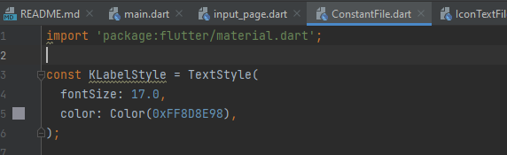

Now, its use. Also import constant file wherever you will use this.

Expanded(  
 child: RepeatContainerCode(  
 onPressed: () {},  
 colors: Color(0xFF1D1E33),  
 cardWidget: Column(  
 children: [  
 Text(  
 'Height',  
 style: KLabelStyle,  
 ),  
 ],  
 ),  
 ),  
),